**Creating a REACT JS Application**

1. Install Visual studio code.
2. Install Node
3. Install npm
4. Install create-react-app template globally



1. Create a new React app with name helloworld



1. This creates a new directory with the following file structure:

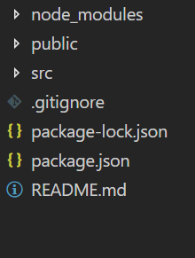

1. Looking at helloworld/package.json, we note a dependency: **react-scripts**

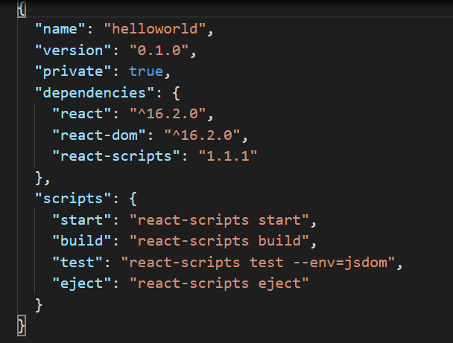

* 1. react-scripts is an NPM package specifically for use with create-react-app. It's the "black box" which contains the essentials:
  2. Dependencies: Like Babel, ESLint, and Webpack.
  3. Configuration: Config files for Webpack, Babel and ESLint, both for development and production.
  4. Scripts: For instance, the command react-scripts start runs a script shipped with this package. It's responsible for ultimately booting the Webpack development server.

1. Index.html has the root div element.

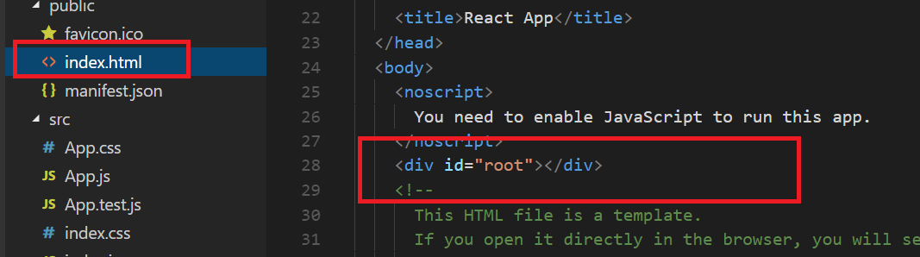

1. The App component is rendered in the root div from index.js file

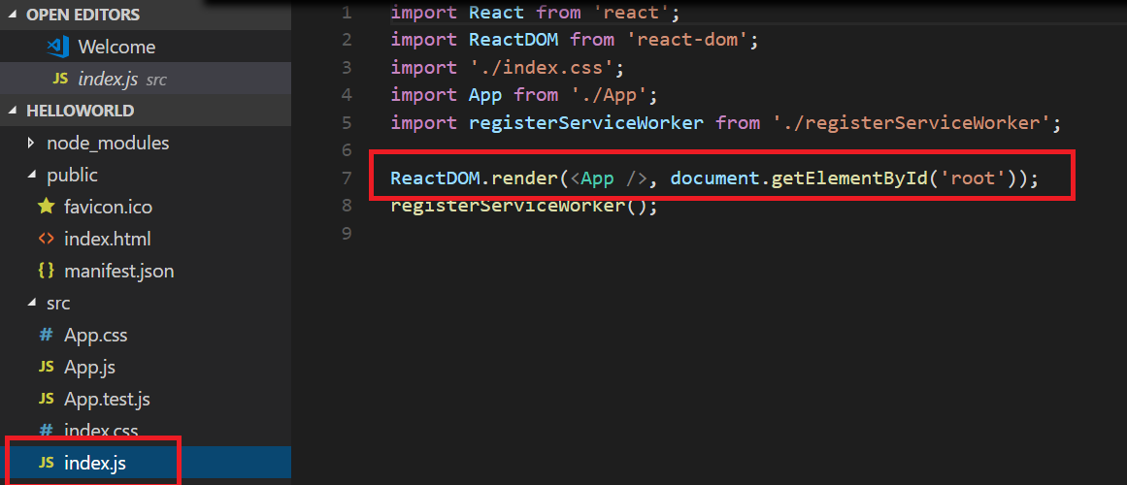

1. App component has the App class inheriting React.Component and the render method has the required html.

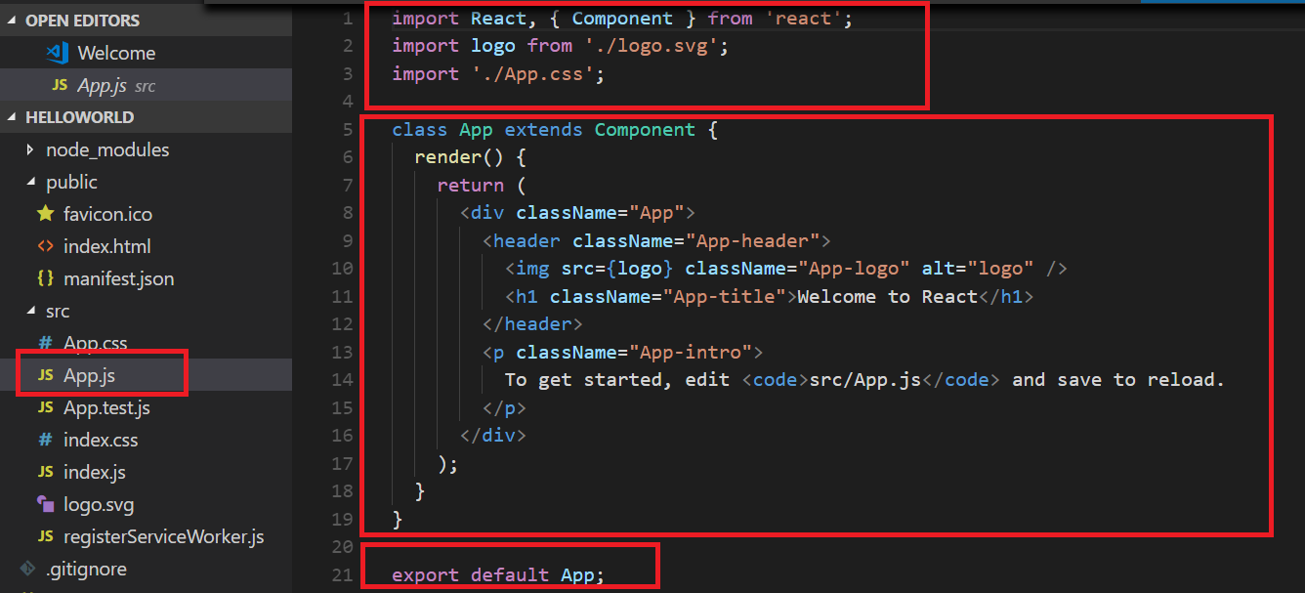

1. Run the helloworld React app using **npm start** command inside the directory helloworld. This will launch a Webpack dev server and should also open localhost:3000 in your browser.

